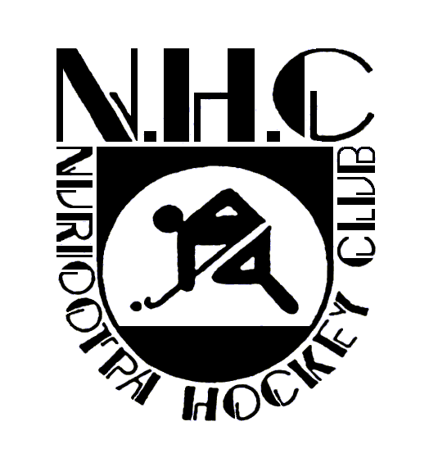

**CODES OF BEHAVIOR**

**Spectator**

As a spectator watching an event that is conducted or sanctioned by the Nuriootpa Hockey

Club, you must meet the following requirements with regard to your conduct.

Spectators are an important part of the game and shall at all times conform to accepted

standards of good sportsmanship and behaviour.

1. Spectators shall at all times respect officials, coaches and players and extend all

courtesies to them.

2. Lead by example and respect all players, coaches, umpires and fellow spectators –

physical or verbal abuse will not be tolerated.

3. Respect the umpires’ decision. Do not abuse, threaten or intimidate an umpire or

match official and do not show dissension, displeasure or disapproval towards an

umpire or match official’s decision in an abusive or unreasonable fashion.

4. Support skilled performances and show respect for opposition teams and players.

5. Display appropriate social behaviour by not using profane, demeaning or derogatory

language, or harassing players, coaches, officials or other spectators.

6. Leave the spectator area tidy and free from litter.

7. Do not ridicule mistakes or losses – supporters are there to support.

8. Acknowledge all volunteers who are giving up their valuable time to enable the

conduct of competition.

9. Respect the rights, dignity and worth of every person regardless of their gender,

ability, cultural background or religion.

The Club’s Committee is responsible for ensuring that this Code of Behaviour is met at all

times.

Authorised and Endorsed by the Nuriootpa Hockey Club Committee 2022

Brad Fairey

President